ITProTV

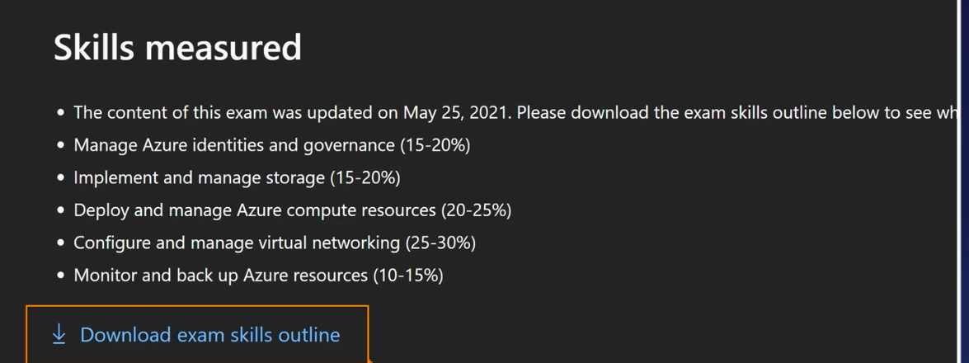

May 30 2022

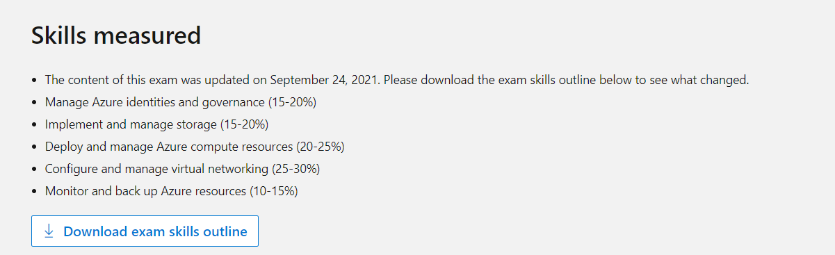

# Manage Azure identities and governance (15–20%)

## Manage Azure Active Directory (Azure AD) objects

**create users and groups**

**create administrative units**

**manage user and group properties**

**manage device settings**

**perform bulk user updates**

**manage guest accounts**

**configure Azure AD join**

**configure self-service password reset**

## Manage role-based access control (RBAC)

* create a custom role
* provide access to Azure resources by assigning roles at different scopes
* interpret access assignments

## Manage subscriptions and governance

* configure Azure policies
* configure resource locks
* apply and manage tags on resources
* manage resource groups
* manage subscriptions
* manage costs
* configure management groups

# Implement and manage storage (15–20%)

## Secure storage

* configure network access to storage accounts
* create and configure storage accounts
* generate shared access signature (SAS) tokens
* manage access keys
* configure Azure AD authentication for a storage account
* configure access to Azure Files

## Manage storage

* export from Azure job
* import into Azure job
* install and use Azure Storage Explorer
* copy data by using AZCopy
* implement Azure Storage replication
* configure blob object replication

## Configure Azure files and Azure Blob Storage

* create an Azure file share
* create and configure Azure File Sync service
* configure Azure Blob Storage
* configure storage tiers
* configure blob lifecycle management

# Deploy and manage Azure compute resources (20–25%)

## Automate deployment of virtual machines (VMs) by using Azure Resource Manager templates

* modify an Azure Resource Manager template
* configure a virtual hard disk (VHD) template
* deploy from a template
* save a deployment as an Azure Resource Manager template
* deploy virtual machine extensions

## Configure VMs

* configure Azure Disk Encryption
* move VMs from one resource group to another
* manage VM sizes
* add data disks
* configure networking
* redeploy VMs
* configure high availability
* deploy and configure virtual machine scale sets

## Create and configure containers

* configure sizing and scaling for Azure Container Instances
* configure container groups for Azure Container Instances
* configure storage for Azure Kubernetes Service (AKS)
* configure scaling for AKS
* configure network connections for AKS
* upgrade an AKS cluster

## Create and configure Azure App Service

* create an App Service plan
* configure scaling settings in an App Service plan
* create an App Service
* secure an App Service
* configure custom domain names
* configure backup for an App Service
* configure networking settings
* configure deployment settings

# Configure and manage virtual networking (25–30%)

## Implement and manage virtual networking

* create and configure virtual networks, including peering
* configure private and public IP addresses
* configure user-defined network routes
* implement subnets
* configure endpoints on subnets
* configure private endpoints
* configure Azure DNS, including custom DNS settings and private or public DNS zones

## Secure access to virtual networks

* create security rules
* associate a network security group (NSG) to a subnet or network interface
* evaluate effective security rules
* implement Azure Firewall
* implement Azure Bastion

## Configure load balancing

* configure Azure Application Gateway
* configure an internal or public load balancer
* troubleshoot load balancing

## Monitor and troubleshoot virtual networking

* monitor on-premises connectivity
* configure and use Azure Monitor for Networks
* use Azure Network Watcher
* troubleshoot external networking
* troubleshoot virtual network connectivity

## Integrate an on-premises network with an Azure virtual network

* create and configure Azure VPN Gateway
* create and configure Azure ExpressRoute
* configure Azure Virtual WAN

# Monitor and back up Azure resources (10–15%)

## Monitor resources by using Azure Monitor

* configure and interpret metrics
* configure Azure Monitor logs
* query and analyze logs
* set up alerts and actions
* configure Application Insights

## Implement backup and recovery

* create a Recovery Services vault
* create a Backup vault
* create and configure backup policy
* perform backup and restore operations by using Azure Backup
* perform site-to-site recovery by using Azure Site Recovery
* configure and review backup reports

**The exam guide below shows the changes that were implemented on September 24, 2021.**

ITPROTV Course

User Source – Azure AD(cloud only identities), Microsoft Account(Used to create subscription), Windows Server AD (From on premises), Guest

Create a user or invite user (Guest)

On Premise accounts cannot be edited in Azure Active Directory

Azure Cli – **az** ad user create

Powershell - Connect-azureAD

Creating User via powershell needs 4 parameters. Displayname, password profile, upn and mailnickname

Deleted users are available for 30 days

### Create and Manage Groups

Group types – Security and Microsoft 365

Security – Assign permissions, roles and it’s a main type of group

Microsoft 365 – Shared mailboxes, access to Sharepoint

Membership type for groups – Assigned, dynamic user and dynamic device

Assigned – Specify who is the member of the group.

You cannot change the group type

You can change the membership type

Dynamic Users – Conditional rules.

Dynamic Device – Conditional rules

Via Azure Cli - Create a group – az ad group create –display-name “blaa” –mail-nickname “blaa”

Via Azure PS – Connect-AzureAD | New-AzureADGroup -**DisplayName**”” -**MailEnabled** $value -**SecurityEnabled** $value -**MailNickName** “NotSet”

Security Enabled – AD group. If this is set to false then you will create Office 365 group

### Manage Guest Account